Creating a Word Document in Office 365
- Type office.madisonk12.us into the browser toolbar.
- Sign in using your school email address: firstname.lastname@madisonk12.us and your normal password (whatever you use to sign into the computers here). MAKE SURE YOUR SPELLING IS CORRECT.
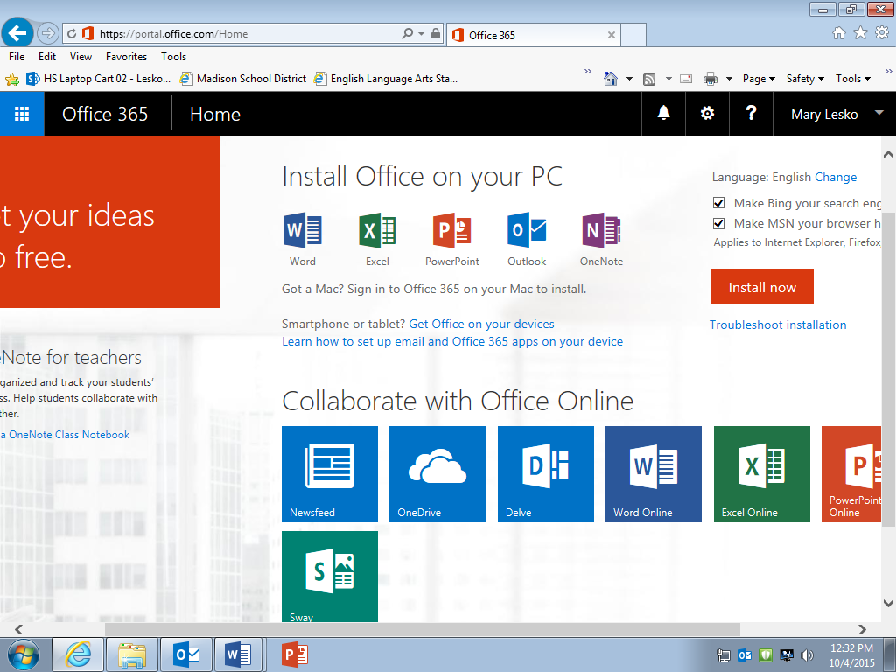
- Your screen after signing in should look like this:
- Select Word Online.
- Click on “New Blank Document”.
- Begin typing.
- Title your document by double-clicking where it says, “Document #” at the top of the screen. Use your first initial, last name, then AP Language Summer Work.
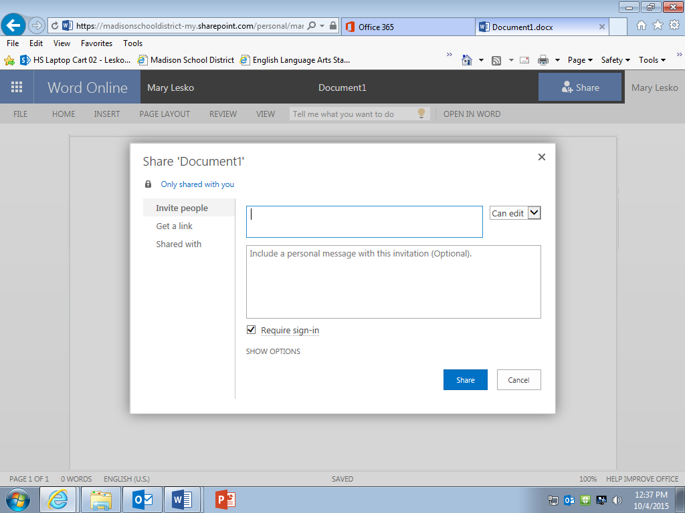
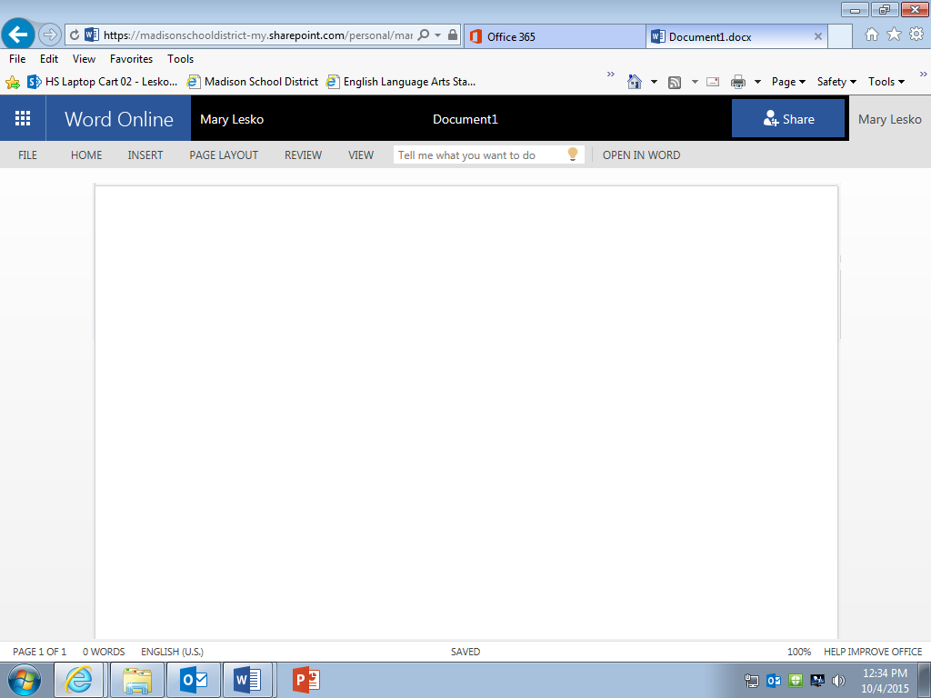
- Click the blue “Share” button. Type “Wolf,” select my name, and make sure the dialogue box to the right reads “Can edit.” Hit “Share.” I now have access to your document.

